

Submitted by:
Name: Istiak Alam
ID: 05
Batch: 20
Lab report: 08
Date: 19.11.22
Course: CSE LAB
Course Code: 1202
Lab task Topic: Structured Programming Problems Solve (Loop)

Submitted to:
Nafisa Tabassum

LECTURER, NDUB

Problem No. 01
Name of the problem:
Write a program in C to display n terms of natural number and their sum.
Test Data : 7
Expected Output :
The first 7 natural number is : 1 2 3 4 5 6 7
The Sum of Natural Number upto 7 terms : 28
Introduction
Implementing program in C is very interesting. To implement the problem given above we should remember the procedure to display outcome. That is, we should consider about the required inputs, the particular process that will be applied upon the input data and the output whether it is desired or not. The given problem gives me an opportunity to have an exercise on the procedure.

Program:
//Displaying the numbers 1 to 10 using for loop
#include <stdio.h>
int main()
{
int i,n,sum=0;
printf("Input Value of terms : ");
scanf("%d",&n);
printf("\nThe first %d natural numbers are:\n",n);
for(i=1;i<=n;i++)
{
printf("%d ",i);
sum+=i;
}
printf("\nThe Sum of natural numbers upto %d terms : %d \n",n,sum);
}

Output:
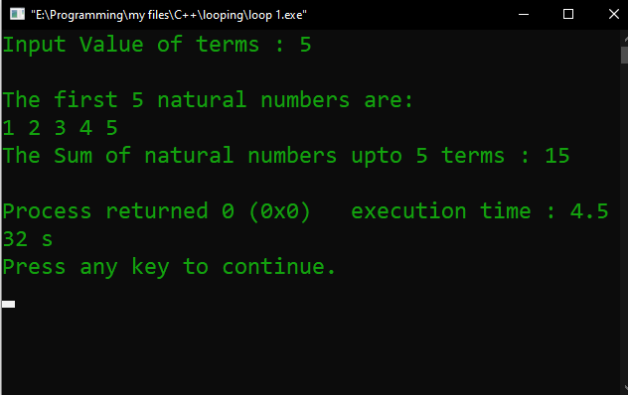

Problem No. 02
Name of the problem:
Write a program in C to read 10 numbers from keyboard and find their sum and average.
Introduction
Implementing program in C is very interesting. To implement the problem given above we should remember the procedure to display outcome. That is, we should consider about the required inputs, the particular process that will be applied upon the input data and the output whether it is desired or not. The given problem gives me an opportunity to have an exercise on the procedure.

Program:
//Display the average of the values loop
#include <stdio.h>
int main()
{
int i,n,sum=0;
float avg;
printf("Input the 10 numbers : \n");
for (i=1;i<=10;i++)
{
printf("Number-%d :",i);
scanf("%d",&n);
sum +=n;
}
avg=sum/10.0;
printf("The sum of 10 no is : %d\nThe Average is : %f\n",sum,avg);
}

Output:
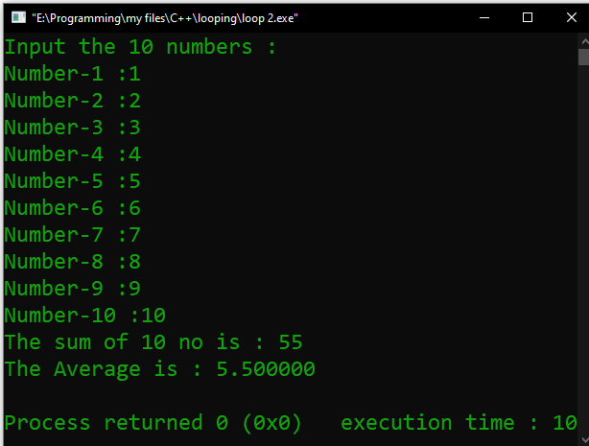

Problem No. 03
Name of the problem:
Write a program in C to display the cube of the number upto given an integer.
Introduction
Implementing program in C is very interesting. To implement the problem given above we should remember the procedure to display outcome. That is, we should consider about the required inputs, the particular process that will be applied upon the input data and the output whether it is desired or not. The given problem gives me an opportunity to have an exercise on the procedure.

Program:
//display the cube of the number up to given an integer
#include <stdio.h>
int main()
{
int i,n,c=0;
float avg;
printf("Input number of terms : \n");
scanf("%d",&n);
for (i=1;i<=n;i++)
{
c=i*i*i;
printf("Number is : %d and cube of the %d is :%d\n",i,i,c);
}
return 0;
}

Output:
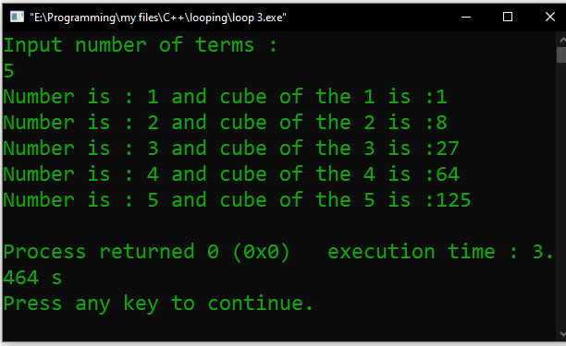

Problem No. 04
Name of the problem:
Write a program in C to display the multiplication table of a given integer.
Introduction
Implementing program in C is very interesting. To implement the problem given above we should remember the procedure to display outcome. That is, we should consider about the required inputs, the particular process that will be applied upon the input data and the output whether it is desired or not. The given problem gives me an opportunity to have an exercise on the procedure.

Program:
//Table of inputed number
#include<stdio.h>
int main()
{
int n,i,t=0;
printf("Enter your n:");
scanf("%d",&n);
for(i=1;i<=10;i++)
{
t=n*i;
printf("%d * %d = %d\n",n,i,t);
}
return 0;
}

Output:
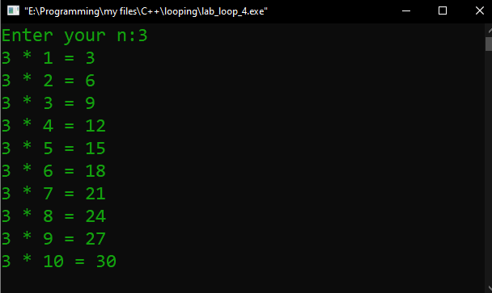

Problem No. 05
Name of the problem:
Write a program in C to display the multiplication table vertically from 1 to n.
Introduction
Implementing program in C is very interesting. To implement the problem given above we should remember the procedure to display outcome. That is, we should consider about the required inputs, the particular process that will be applied upon the input data and the output whether it is desired or not. The given problem gives me an opportunity to have an exercise on the procedure.

Program:
//Table of nth inputed number
#include<stdio.h>
int main()
{
int n,i,t=0,x;
printf("Enter your n:");
scanf("%d",&n);

for(i=1;i<=n;i++)
{
printf("\ntable of %d\n",i);
for(x=1;x<=10;x++)
{
t=x*i;
printf("%d * %d = %d\n",x,i,t);
}
}
return 0;
}
Output


Problem No. 06
Name of the problem:
Write a program in C to display the n terms of odd natural number and their sum
Introduction
Implementing program in C is very interesting. To implement the problem given above we should remember the procedure to display outcome. That is, we should consider about the required inputs, the particular process that will be applied upon the input data and the output whether it is desired or not. The given problem gives me an opportunity to have an exercise on the procedure.

Program:
//display the n terms of odd natural number and their sum
#include <stdio.h>
int main()
{
int i,n,sum=0;

printf("Input number of terms : ");
scanf("%d",&n);
printf("\nThe odd numbers are :");
for(i=1;i<=n;i++)
{
printf("%d ",2*i-1);
sum+=2*i-1;
}
printf("\nThe Sum of odd Natural Number upto %d terms : %d \n",n,sum);
}

Output:
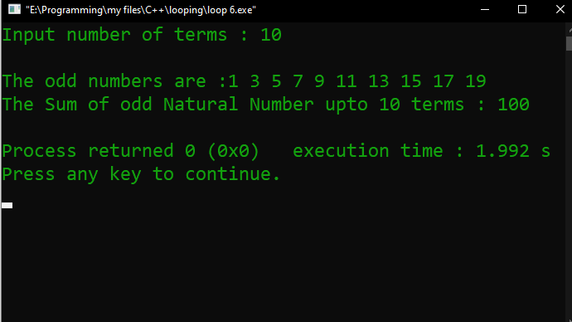

Problem No. 07
Name of the problem:
Write a program in C to display the pattern like right angle triangle using an asterisk.
Introduction
Implementing program in C is very interesting. To implement the problem given above we should remember the procedure to display outcome. That is, we should consider about the required inputs, the particular process that will be applied upon the input data and the output whether it is desired or not. The given problem gives me an opportunity to have an exercise on the procedure.

Program:
//* star looping triangle *-*
#include <stdio.h>
int main()
{
int i,j;
int n;
printf("Enter triangle line numbers:");
scanf("%d",&n);

for(i=1; i<=n; i++)
{
for(j=1; j<=i; j++)
printf("*");
printf("\n");
}
return 0;
}

Output:
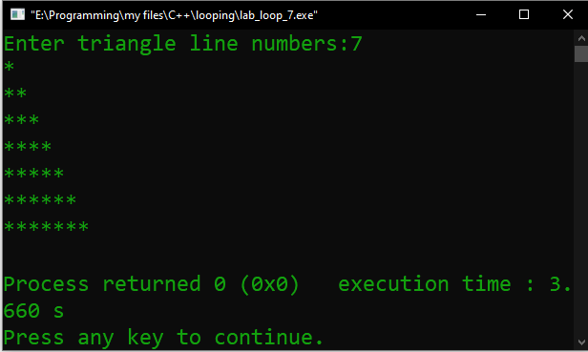

Problem No. 08
Name of the problem:
Write a program in C to display the pattern like right angle triangle with a number
Introduction
Implementing program in C is very interesting. To implement the problem given above we should remember the procedure to display outcome. That is, we should consider about the required inputs, the particular process that will be applied upon the input data and the output whether it is desired or not. The given problem gives me an opportunity to have an exercise on the procedure.

Program:
//display the pattern like right angle triangle with a number
#include <stdio.h>
int main()
{
int i,j,rows;
printf("Input number of rows : ");
scanf("%d",&rows);
for(i=1;i<=rows;i++)
{
for(j=1;j<=i;j++)
printf("%d",j);
printf("\n");
}
}

Output:
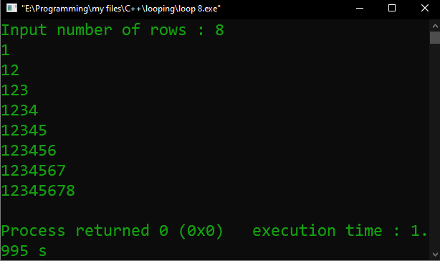

Problem No. 09
Name of the problem:
Write a program in C to make such a pattern like right angle triangle with a number which will repeat a number in a row
Introduction
Implementing program in C is very interesting. To implement the problem given above we should remember the procedure to display outcome. That is, we should consider about the required inputs, the particular process that will be applied upon the input data and the output whether it is desired or not. The given problem gives me an opportunity to have an exercise on the procedure.

Program:
//pattern like right angle triangle with a number which will repeat a number in a row.
#include <stdio.h>
void main()
{
int i,j,rows;

printf("Input number of rows : ");
scanf("%d",&rows);
for(i=1;i<=rows;i++)
{
for(j=1;j<=i;j++)
printf("%d",i);
printf("\n");
}
}

Output:
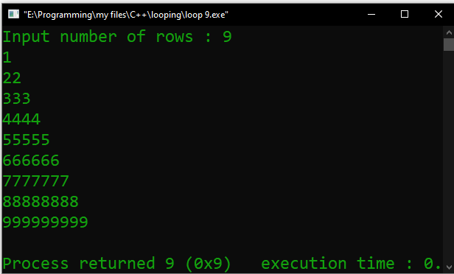

Problem No. 10
Name of the problem:
Write a program in C to make such a pattern like right angle triangle with number increased by 1.
Introduction
Implementing program in C is very interesting. To implement the problem given above we should remember the procedure to display outcome. That is, we should consider about the required inputs, the particular process that will be applied upon the input data and the output whether it is desired or not. The given problem gives me an opportunity to have an exercise on the procedure.

Program:
//pattern like right angle triangle with a number which will repeat a number in a row.
#include <stdio.h>
void main()
{
int i,j,rows;

printf("Input number of rows : ");
scanf("%d",&rows);
for(i=1;i<=rows;i++)
{
for(j=1;j<=i;j++)
printf("%d",i);
printf("\n");
}
}

Output:
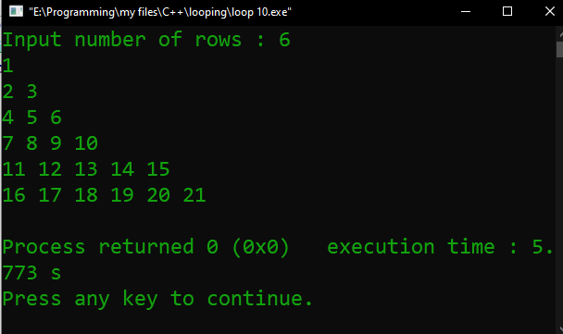

Problem No. 11
Name of the problem:
Write a program in C to make such a pattern like a pyramid with numbers increased by 1.
Introduction
Implementing program in C is very interesting. To implement the problem given above we should remember the procedure to display outcome. That is, we should consider about the required inputs, the particular process that will be applied upon the input data and the output whether it is desired or not. The given problem gives me an opportunity to have an exercise on the procedure.

Program:
//pattern like a pyramid with numbers increased by 1.
#include <stdio.h>
int main()
{
int i,j,spc,rows,k,t=1;
printf("Input number of rows : ");
scanf("%d",&rows);
spc=rows+4-1;
for(i=1;i<=rows;i++)
{
for(k=spc;k>=1;k--)
{
printf(" ");
}
for(j=1;j<=i;j++)
printf("%d ",t++);
printf("\n");
spc--;
}}
Output:
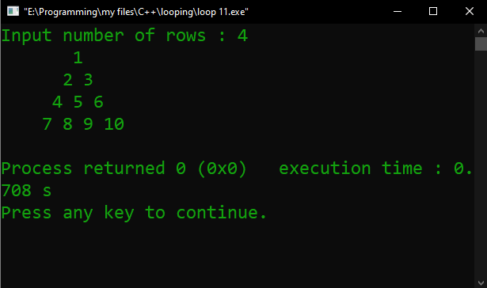

THE END

